SUPERVISION
Canceled

Email
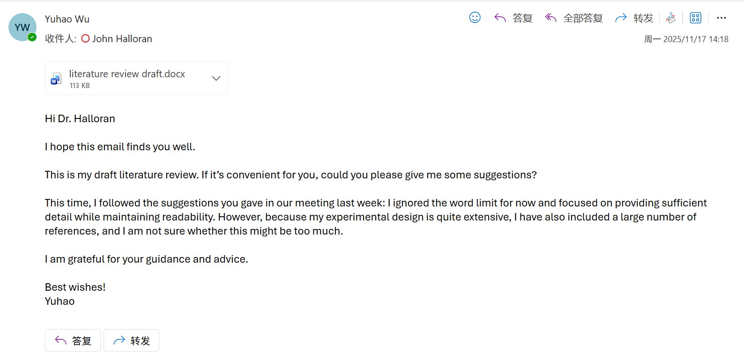

Computing Project
WORK DONE
1. Complete the measurement of model size, inference latency, and energy consumption for all models.
2. Organise all the code from previous experiments and upload it to GitHub one by one.
3. Organise the project progress, especially the weekly progress reports, written explanations, email correspondence with my supervisor, meeting notes, etc.
4. I have designed a third new model, RCCMix.
5. Conduct an in-depth analysis of RCCMix.
6. Prepare the presentation and submit the slide deck on Aula.

Issues and challenges
I feel very busy because the experimental workload is very heavy.
Because there are many models, I can only select a representative subset for in-depth analysis.

Actions for next week
1. Complete the first draft of the dissertation.
2. If time allows, add more in-depth analysis and explanation of RCCMix.

